Restaurant

Note : This app is Based on Web Service (SOAP)

Base URL : Soap Web Service:

**"http://e-smartrestaurant.com/ESmartRestaurantService/ESmartRestaurantService.asmx"**

* Login Types:

1. Manager
2. Waiter
3. Kitchen
4. Manager

He/She want UserName or Password for Login.

* 1. Table Status

He/She can view the table Status ..whether the is free or occupied.

Web service-**GetTable**

* 1. New Order

He/She can view the table whiich are free..and can start taking New Order.

Web service-**GetTable, InsertOrder, insertMergetable, UpdateTable**

* 1. Existing Order

He/She can view the table which are occupied.

Can add new order to exixting table.

Can Shift table ,split table or can update the person count

Web Service-**GetExistingTable, UpdateTable**

* 1. View Order

He/She can view the Order details ..accc to table

**Web Service-UpdateOrder**, **InsertOrderTrasaction**

* 1. Take Away

He/She can orde Parcel

**Web Service-GetRegister, InsertOrder**

* 1. Menu

He/She can view the Menu

Web service- **GetCategory, GetMenu**

* 1. Bill

He/She can view the total bill amount and the order that have given.

**Web Service-GetExistingTable,GetOrder,UpdateOrder**

* 1. Amount Wise Pie chart

Can view top 10 product in amount wise

Web Service- **GetChart**

* 1. Quantity wise Pie Chart

Can view top 10 product in quantity wise

1. Waiter

He/She want UserName or Password for Login.

* 1. Table Status

He/She can view the table Status ..whether the is free or occupied.

Web service-**GetTable**

* 1. New Order

He/She can view the table whiich are free..and can start taking New Order.

Web service-**GetTable, InsertOrder, insertMergetable, UpdateTable**

* 1. Existing Order

He/She can view the table which are occupied.

Can add new order to exixting table.

Can Shift table ,split table or can update the person count

Web Service-**GetExistingTable, UpdateTable**

* 1. View Order

He/She can view the Order details ..accc to table

**Web Service-UpdateOrder**, **InsertOrderTrasaction**

* 1. Take Away

He/She can orde Parcel

**Web Service-GetRegister, InsertOrder**

* 1. Menu

He/She can view the Menu

Web service- **GetCategory, GetMenu**

* 1. Bill

He/She can view the view the total bill amount and the order that the have given.

**Web Service-GetExistingTable,GetOrder,UpdateOrder**

1. Kitchen

He/She want UserName or Password for Login.

* 1. Table Order

He/She can view the Order details

Web service- **GetKichenOrderList, GetKichenOrderDetails, UpdateOrder**

1. Order Transaction detail..

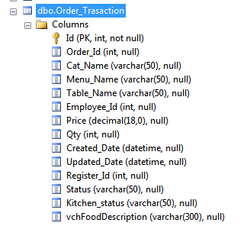

2.Order detail (Table and amount)

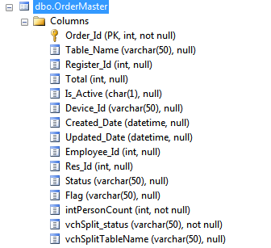

3.Menu details

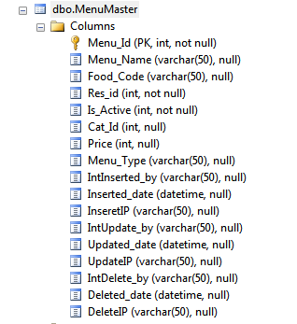

4.Registration details

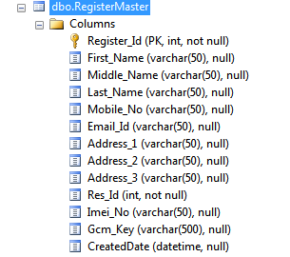

5.Table Details

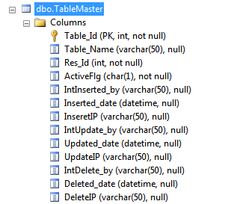

6.Merge table

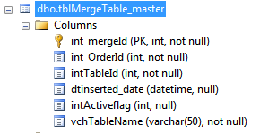

7. Category table

